Deploying Amazon RDS Multi-AZ and Read Replica, Simulate Failover

Introduction

What is Amazon RDS?

Amazon RDS
- Amazon Relational Database Service (Amazon RDS) is a Relational Database service that offers high availability and throughput.
- Amazon RDS comes with great features that include Multi-AZ feature and Read Replica that ensures no data loss.
- Amazon RDS also provides you high scalability where you can scale up and scale down depending on your needs.
- Amazon RDS provides you with six familiar database engines which include MySQL, Amazon Aurora, PostgreSQL, MariaDB, Oracle Database and SQL Server.

Multi-AZ
- Multi-Availability zone (Multi-AZ) is a feature that comes with Amazon RDS that provides you with high availability and durability for Database instances.
- When we are opting for the Multi-AZ database instance, it will automatically create a Primary DB instance and parallelly replicate the data to the standby instances in different availability zones in that region. However, we can't access the standby instances, unlike primary instances.
- The main purpose of Multi-AZ is to provide a failover option for primary RDS instances.
- Amazon RDS uses the Failover mechanism for Oracle, MYSQL, MariaDB and PostgreSQL instances.
- The RDS Failover process happens automatically and is managed by AWS without human intervention.
- Amazon RDS uses the concept of SQL Mirroring for Replicating data to standby instances in the different availability zones, and both primary and standby instances use the same endpoint.

Reasons for Failover
- The failover process will take place due to one of the following reasons, occurring in the primary instances:
  - Host Failure
  - DB instance class modification.
  - Instance rebooting
  - Availability zone failure
  - RDS maintenance

Conditions for enabling Multi-AZ on RDS
- A minimum of two different availability zones should be present in a DB subnet group where you are launching your Primary DB instance.

Amazon Aurora and Read Replica

- Amazon Aurora is the DB instance, which is a little different when comparing to the above-mentioned Instance types.
- Aurora uses the concept of a DB cluster, where the primary instance replicates its data across different availability zones.
- In the case of a primary instance failure, Aurora automatically launches its primary instance from the replicated instance in a different availability zone.
- Multi-AZ on Aurora clusters makes RDS replicate or provision a replica of the master database to a different availability zone within a Region.

Architecture Diagram

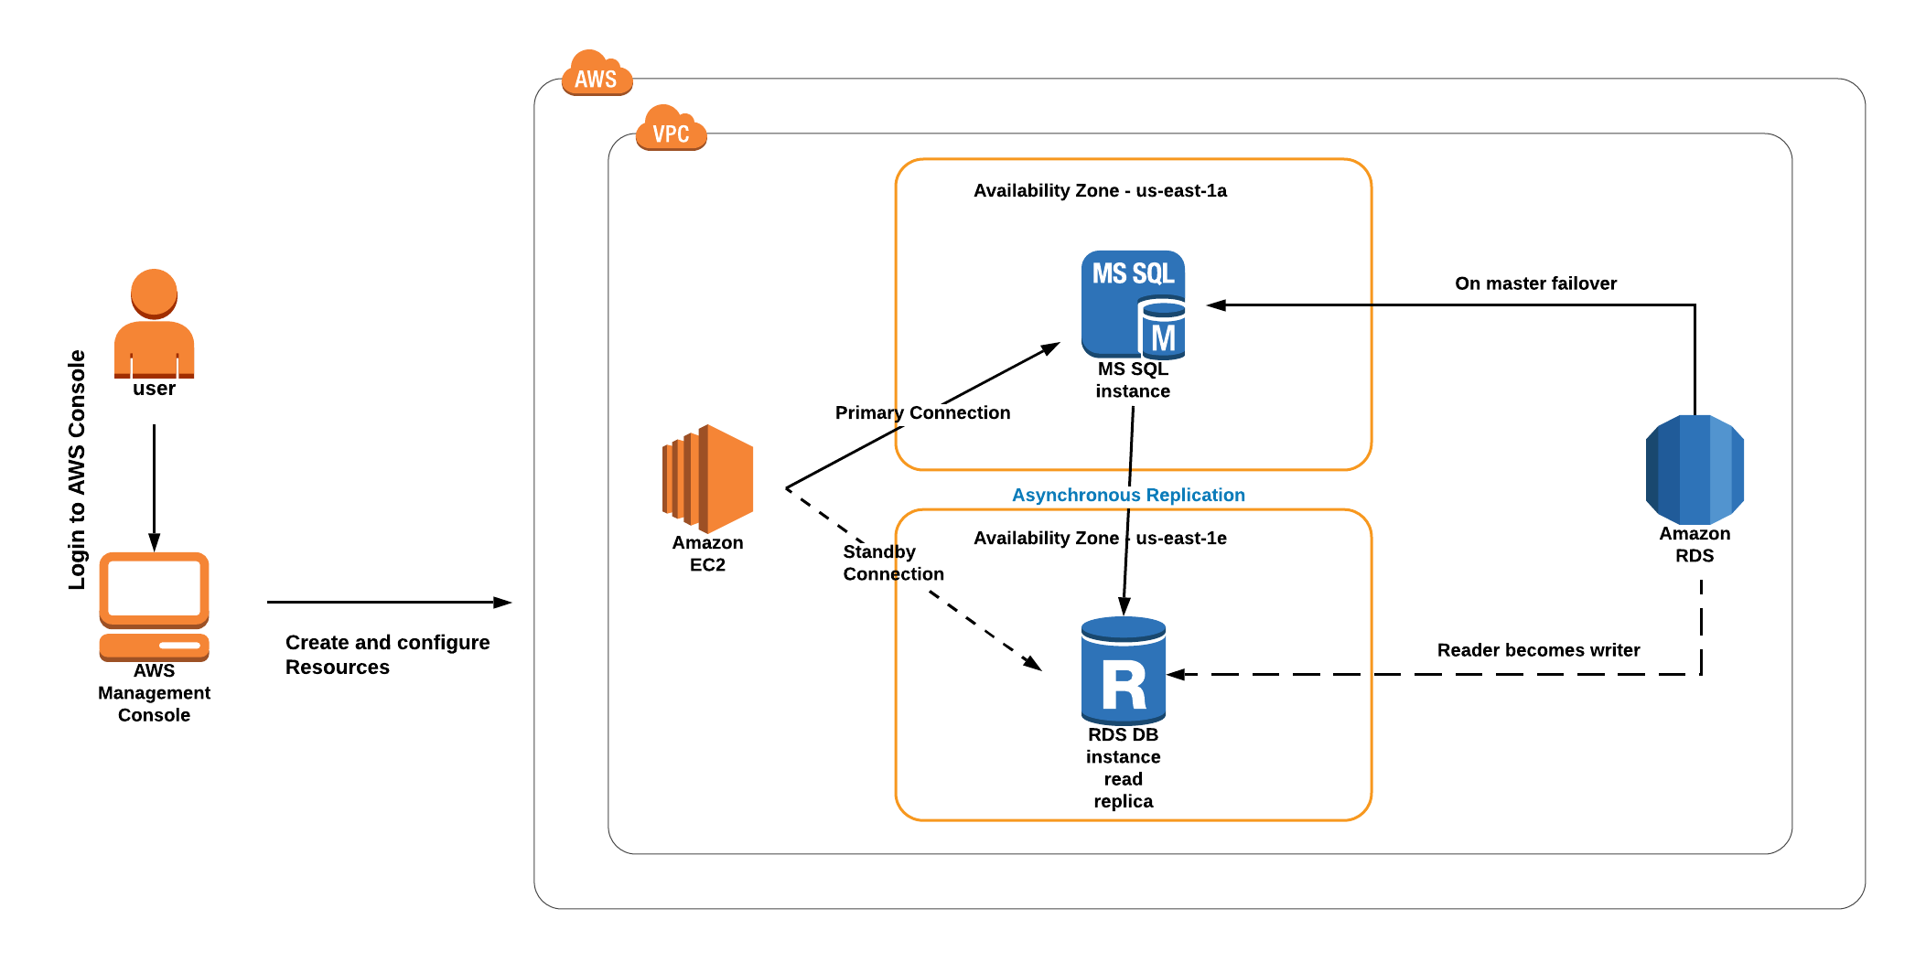

Lab Steps

Task 1: Sign in to AWS Management Console
- Click on the Open Console button, and you will get redirected to AWS Console in a new browser tab.
- On the AWS sign-in page,
  - Leave the Account ID as default. Never edit/remove the 12-digit Account ID present in the AWS Console. Otherwise, you cannot proceed with the lab.
  - Now copy your Username and Password in the Lab Console to the IAM Username and Password in AWS Console and click on the Sign in button.
- Once Signed In to the AWS Management Console, make the default AWS Region as US East (N. Virginia) us-east-1.

Task 2: Launch an EC2 instance
In this task, we are going to launch an EC2 instance which will be used for connecting to the Amazon Aurora RDS DB instance later in the lab.
- Navigate to EC2 by clicking on the Services menu in the top, then click on EC2 in the Compute section.
- Click on Instances from the left sidebar and then click on Launch instances
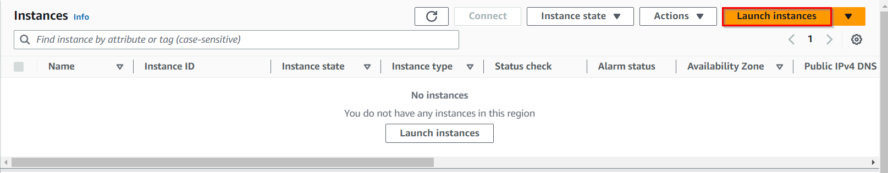
- Name : Enter MyRdsEc2server
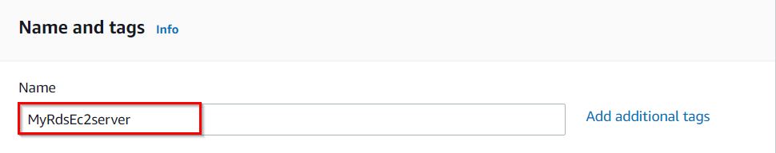
- For Amazon Machine Image (AMI): In Quick Start menu, select Amazon Linux 2023 AMI.
- For Instance Type: select t2.micro

- For Key pair: Select Create a new key pair
  - Key pair name: MySSHKey
  - Key pair type: RSA
  - Private key file format: .pem
Note: If you are using putty, select the Private key file format as .ppk
- Select Create key pair Button.
- In Network Settings, Click on Edit:
- Auto-assign public IP: Enable
- Select Create new Security group
- Security group name : Enter MyEC2Server_SG
- Description : Enter Security for ec2 server to connect with RDS
  - To add SSH:
  - Choose Type: SSH
  - Source: select Anywhere

Follow these steps to install it.
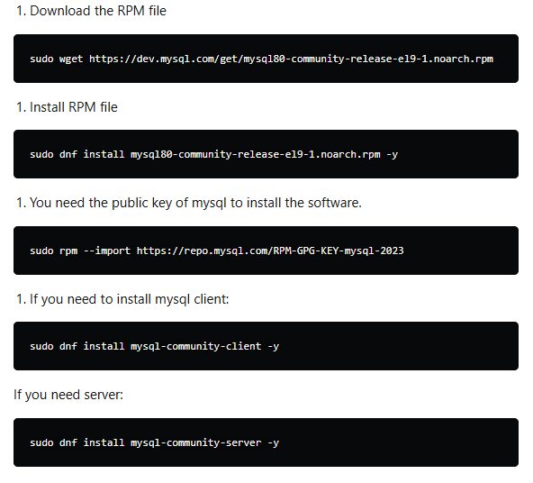-y

Note: After pasting the user data, make sure to remove extra spacing.
- Keep rest thing Default and Click on Launch Instance Button.
- Select View all Instances to View the Instance you Created
- After 1-2 minutes, the Instance State will become running as shown below:
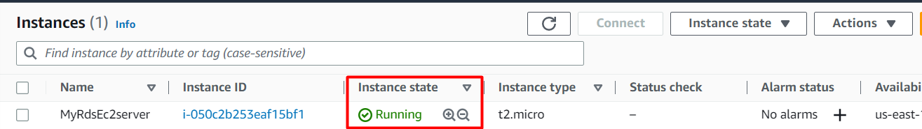
- Select the EC2 Instance and copy the Private IPv4 address. Note down IPv4 Private IP address in your text editor, navigate to the EC2 Dashboard and look in the instance details.

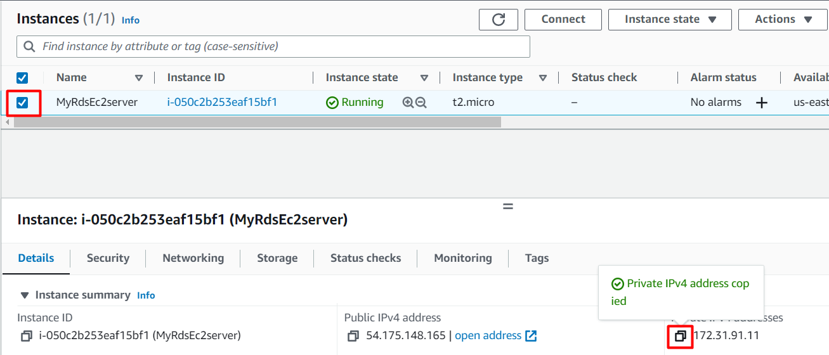

Task 3: Create a Security Group for RDS instance
In this task, we will create a security group specifically for the Amazon Aurora RDS instance which ensures that the RDS instance has appropriate network security settings by allowing access only through the MySQL/Aurora port (3306) from any IP address (0.0.0.0/0).
- Make sure you are in the N.Virginia Region.
- Navigate to EC2 by clicking on the Services menu available under the Compute section.
- On the left panel menu, select the security group under the Network & Security section.
- Click on the Create security group button.
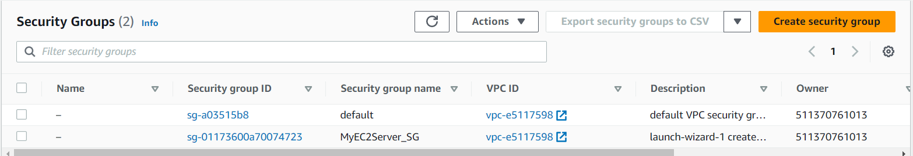
- We are going to create a Security group for RDS with 3306 port number enabled.
  - Security group name : Enter rds-maz-SG
  - Description : Enter Security group for RDS Aurora
  - VPC : Select Default VPC
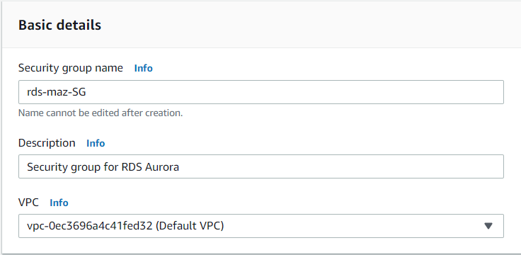
- Click on the Add rule button under Inbound rules.
  - Type : Select MYSQL/Aurora
  - Source : Select Anywhere IPv4
- Leave everything as default and click on the Create security group button.

Task 4: Create an Amazon Aurora database with Multi-AZ enabled
In this task, we will create an aurora database using AWS RDS service. The database is configured with Multi-AZ deployment, which replicates data to a standby instance in a different availability zone, providing high availability and durability.
- Make sure you are in US East (N.Virginia) us-east-1 Region.
- Navigate to RDS under the database section of the Services menu.
- Click on Databases in the left Panel.
- Click on Created database button.

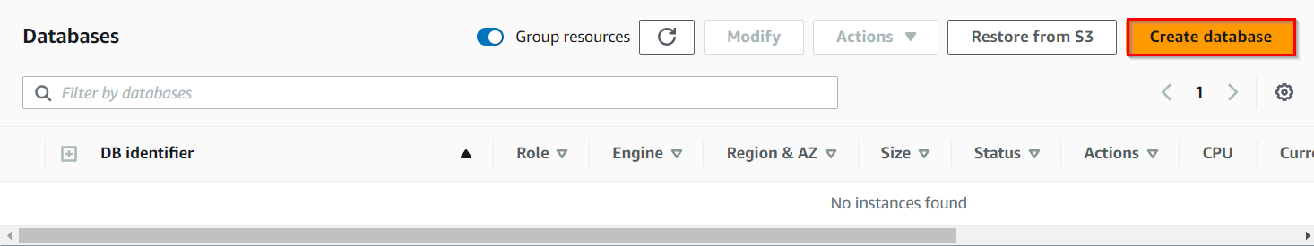

- Next, we'll configure the database on the Create Database Page
  - Choose a Database Creation Method:
    - Select Standard Create
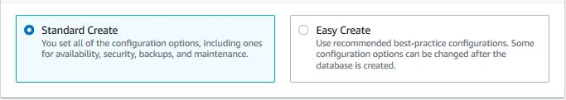
- In Engine options:
- Engine type : Choose Aurora (MySQL Compatible)
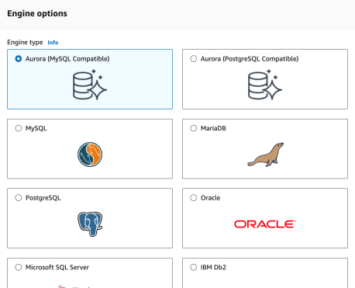
- Available versions: Leave it as Default
- Choose Template: Dev/Test
- Fill in the required details for the database (Aurora Cluster Settings)
- DB cluster identifier: Specify cluster name MyAuroraCluster
- Give the following details in the credential settings
- Master Username: Enter WhizlabsAdmin
- Master password: Enter Whizlabs123
- Confirm password: Enter Whizlabs123
- Note: This is the username and password used to log into your database. Please make note of them.
- Choosing DB instance size
- DB instance class: Choose Burstable classes (includes t classes)
- Select db.t3.medium instance.
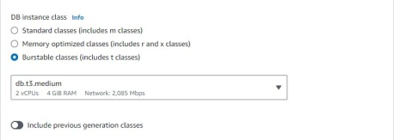

- Availability and Durability: Choose Multi-AZ deployment: Create Aurora Replica or Reader node in a different AZ as shown below:
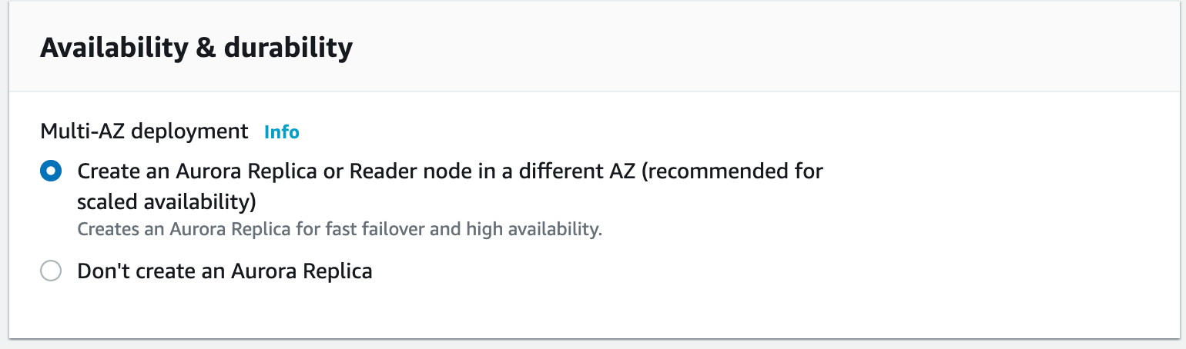
- Connectivity
  - Choose the Default VPC
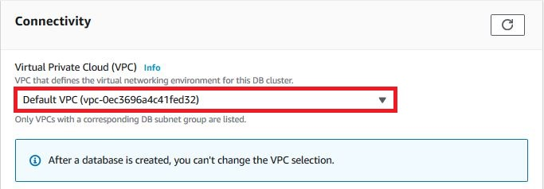
- Additional connectivity configuration
  - Subnet group: Default
  - Publicly accessible: Yes {IMPORTANT}
  - Existing VPC security groups :
    - Remove the Default security group, which is selected by default :
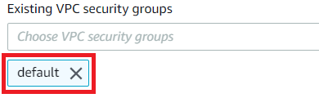
- Select rds-maz-SG for the dropdown.(This is the security group which you have created in the beginning)
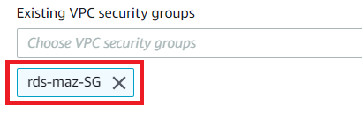
- Additional configuration:
  - Database options
    - Initial database name: Enter whizlabsrds
  - Enable Encryption : Uncheck
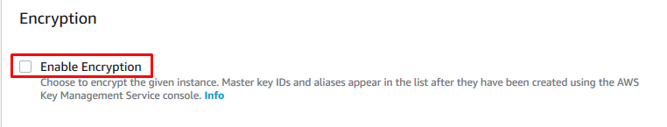
- Leave other settings as default
- Once the details above have been filled in, click on Create database button.
- It will take around 10-15 minutes for the database to be created. Please wait until database status changes from creating to Available.
- Once the database has been created, you should see the following page:

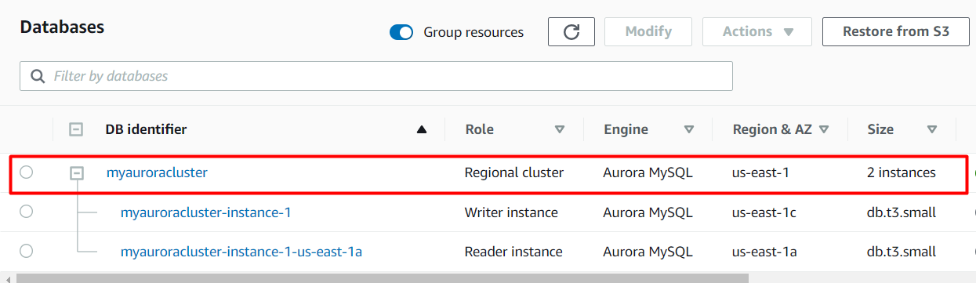

- Similar to the screenshot, you should be able to see that our database launched in multiple AZs, namely us-east-1c and us-east-1a

Task 5: Connecting to the Aurora (MySQL) database on RDS
Now we have successfully launched Aurora RDS with Multi-AZ enabled. To connect to the new Aurora database, we need the endpoint.
- Click on the RDS cluster name and then navigate to Connectivity & security to find the endpoint of your Master (Writer) and Reader instances, with which you can connect to your DB instance.

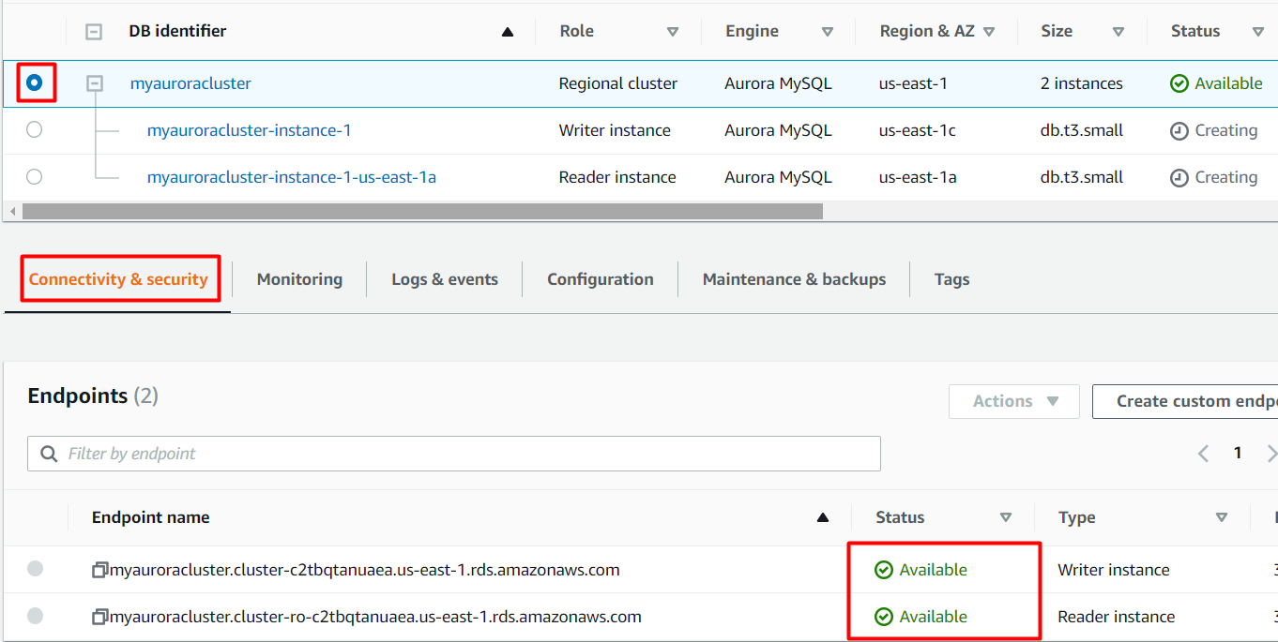

The endpoints you see to be similar to these examples:
Master (Writer): myauroracluster.cluster-c2tbqtanuaea.us-east-1.rds.amazonaws.com
Reader: myauroracluster.cluster-ro-c2tbqtanuaea.us-east-1.rds.amazonaws.com



Note: Please carefully look at the role of the DB instance (reader vs Master (Writer)) and their respective availability zones. (here us-east-1c and us-east-1a)

Task 6: Connecting the EC2 Server to RDS:
In this task, we are going to establish connectivity between the EC2 instance created earlier and the Amazon Aurora RDS database. By modifying the security group of the RDS instance, they allow access from the EC2 instance, enabling communication between the two resources.
- Now we need to connect the RDS with EC2 instance in order to eventually connect with the Aurora database.
- Navigate to RDS available under the Database section of the Services menu.
- Click on Master (writer) database and click on the security group name in this example it is rds-maz-SG under VPC security groups as shown below:

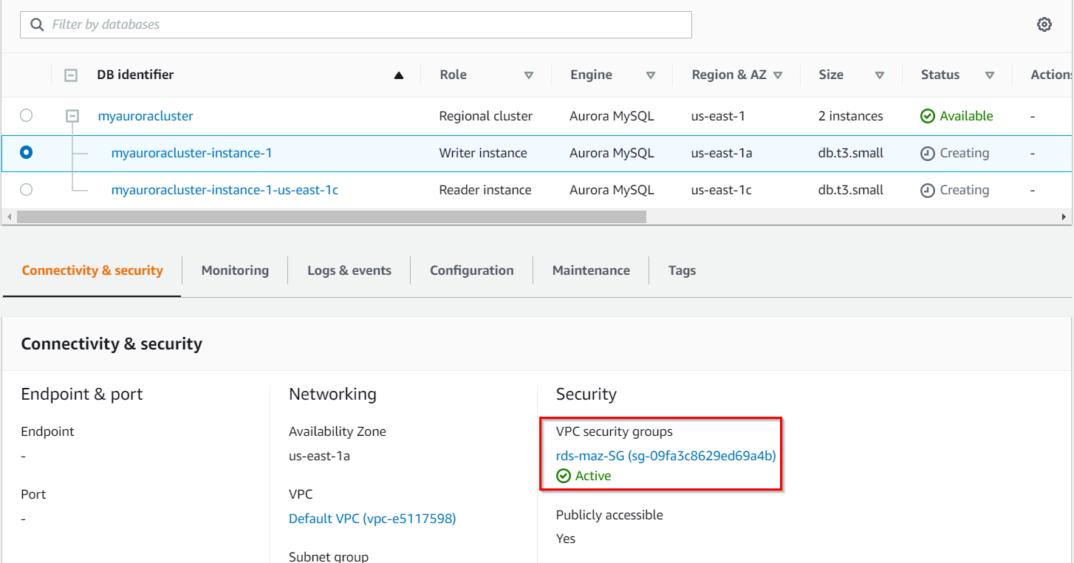

- It will open the Security Group page. Click on Inbound rules.
- Click on Edit inbound rules. The MySQL rule will already exist.
- Click on Add rule button.
  - Type: Select MYSQL/Aurora
  - Source: Paste the Private IP address of your MyRdsEc2server EC2 instance.
  - Delete the old rule and then Click on Save rules button.
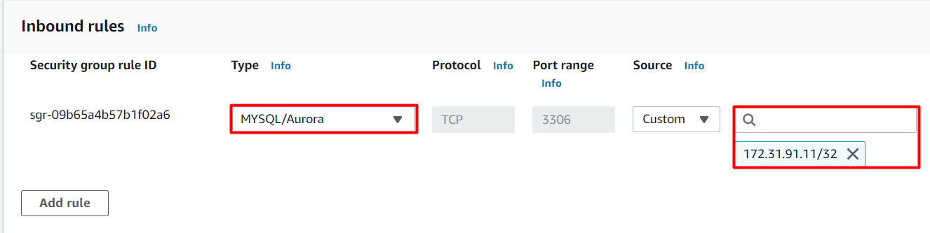

Task 7: Execute Database Operations via SSH
In this task, we are going to execute database operations on the Amazon Aurora RDS database. By SSHing into the EC2 instance and accessing the database using MySQL, they can create tables, insert data, and perform queries.
- Navigate to the EC2 Dashboard and select the instance created.
- Once the instance is launched, Select EC2 Instance Connect option and click on Connect button.
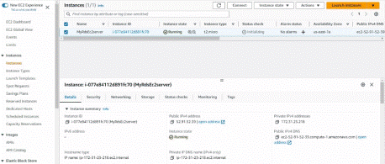
- Please follow the steps in SSH into EC2 Instance for more option to SSH.
- Switch to the root user using the command :

- Log into the RDS instance using the below command:
- mysql -h myauroracluster.cluster-cpoz6c7903cx.us-east-1.rds.amazonaws.com -u WhizlabsAdmin -p
- Syntax: mysql -h <Hostname> -u <username> -p
- Note: Make sure to change the above Master (Writer)Cluster endpoint and Username with yours.
- Host name : myauroracluster.cluster-cpoz6c7903cx.us-east-1.rds.amazonaws.com (Master(Writer)cluster endpoint)
- Username : Enter WhizlabsAdmin
- Password : Enter Whizlabs123 (Use yours incase you changed the password while creating RDS)
- You should now be able to log into the database,
- List all Databases using the below command. You will see the database whizlabsrds created while launching the RDS cluster.

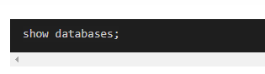

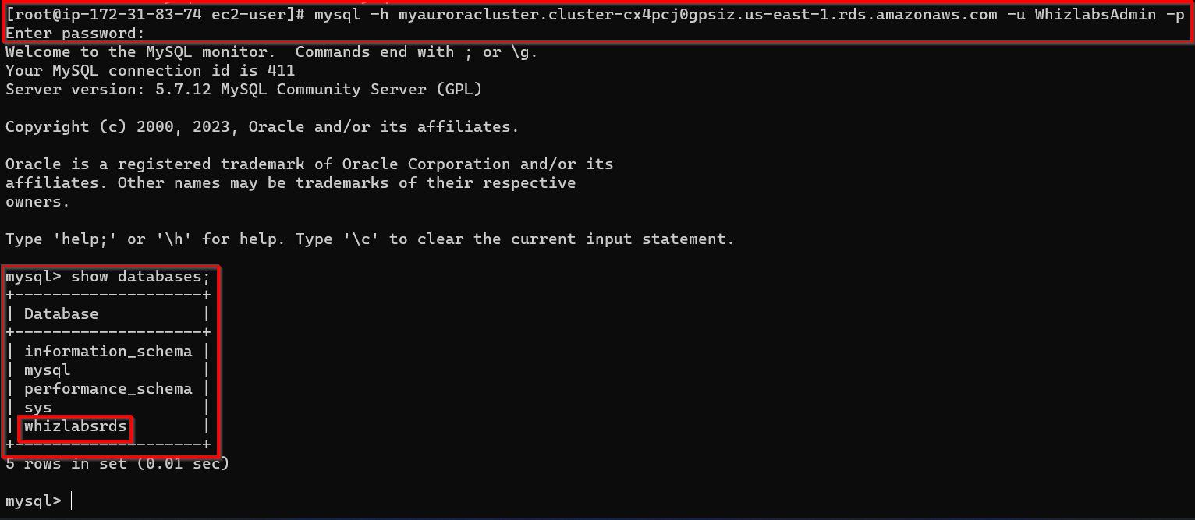

- Now create the database in the Master(Writer) RDS as given in the screenshot. We'll create a demo database named auroro_db.
Create database auroro_db;
- Select the newly-created database:
use auroro_db;
- List all Databases:
Show databases;
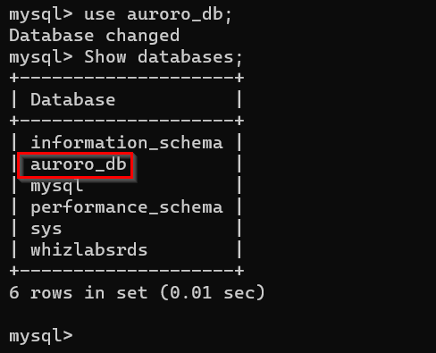
- Next we'll create a table named students and insert few rows of data using list of commands:
CREATE TABLE students ( subject_id INT AUTO_INCREMENT, subject_name VARCHAR(255) NOT NULL, teacher VARCHAR(255),start_date DATE, lesson TEXT,PRIMARY KEY (subject_id));

Select * from students;

Show tables;

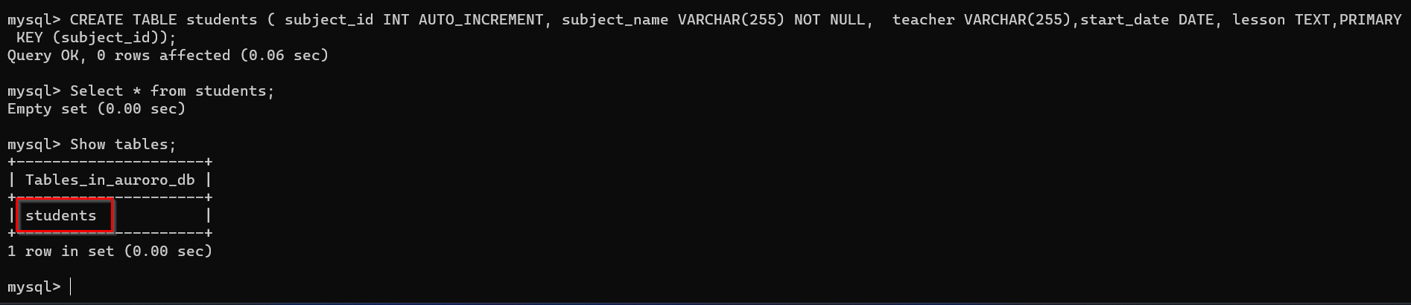
- Insert data into the table:
INSERT INTO students(subject_name, teacher) VALUES ('English', 'John Taylor');
INSERT INTO students(subject_name, teacher) VALUES ('Science', 'Mary Smith');
INSERT INTO students(subject_name, teacher) VALUES ('Maths', 'Ted Miller');
INSERT INTO students(subject_name, teacher) VALUES ('Arts', 'Suzan Carpenter');
- Now you can view the contents of the table student using the below command:
select * from students;
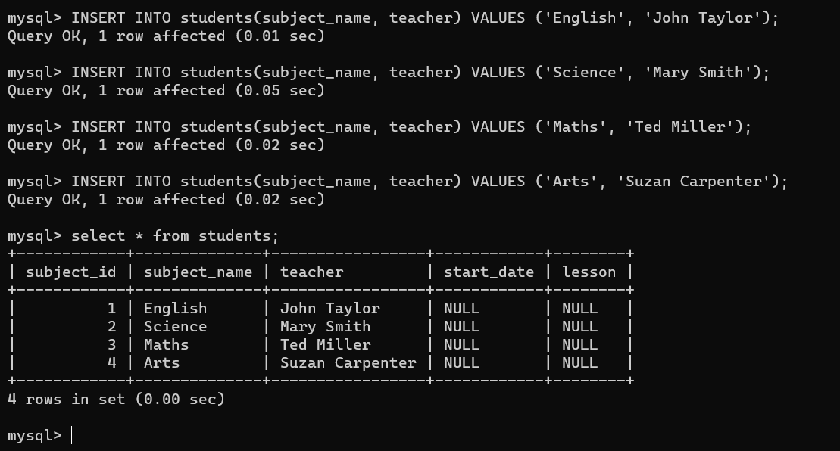
- Exit from mysql console use the below command:
exit;

Task 8: Forcing a Failover to Test Multi-AZ
In this task, we are going to simulate a failover scenario in which the master instance fails, and the read replica takes over as the new master.
- Navigate to RDS Database and in Database section Select Master(Writer) Instance and in Actions dropdown, click on failover
- To test if Multi-AZ is working, we will create a situation where master fails and the read replica has to become the new Master(Writer).
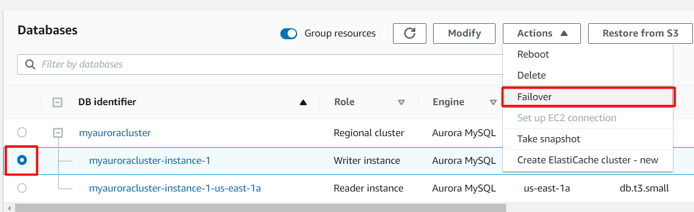

- On the next screen, confirm the Failover.
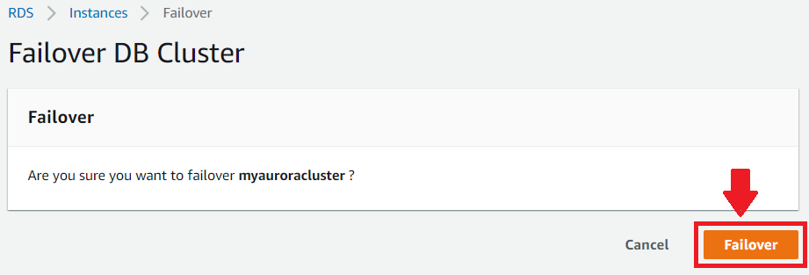

- Wait for a few minutes for the RDS instances to failover.
(i.e Master (Writer) becomes Reader and Reader becomes Master (Writer) as shown below)

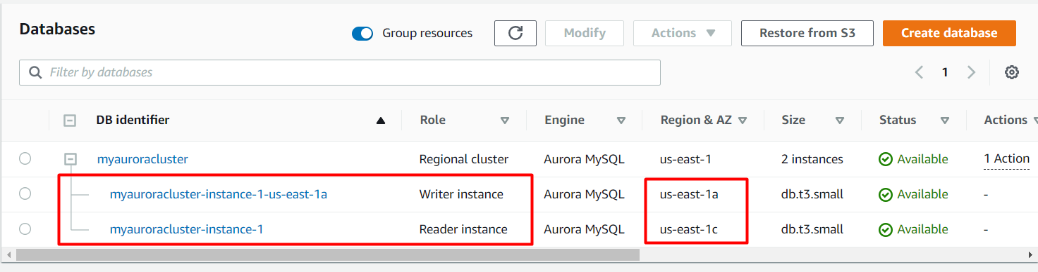

Task 9: Testing the Failover Condition
In this task, we are going to the new master instance and verify the presence of the database, table, and data created earlier. This step ensures that the failover was successful, and the new master instance is functioning as expected.
- Now connect to RDS with new Master endpoint
  - Copy the endpoint of the new Master(Writer)cluster and replace it with your endpoint link.
Mysql -h <endpoint> -u <username> -p and press [Enter]
- mysql -h myauroracluster.cluster-cpoz6c7903cx.us-east-1.rds.amazonaws.com -u WhizlabsAdmin -p
- Password: Enter Whizlabs123
- You will be able to Log into MySQL and check for the database and table created in the master DB instance before the failover.
- You can notice the resources created on the original master db are present, implying that the Failover worked successfully.

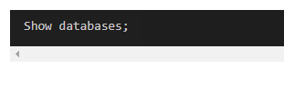

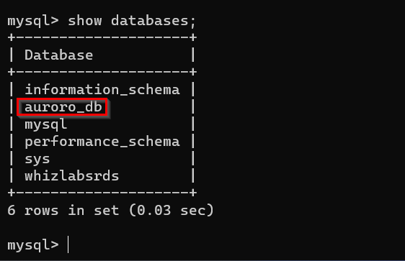

- Now check the existence of table named students and data (that we created earlier in the lab):

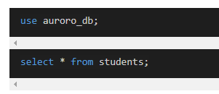
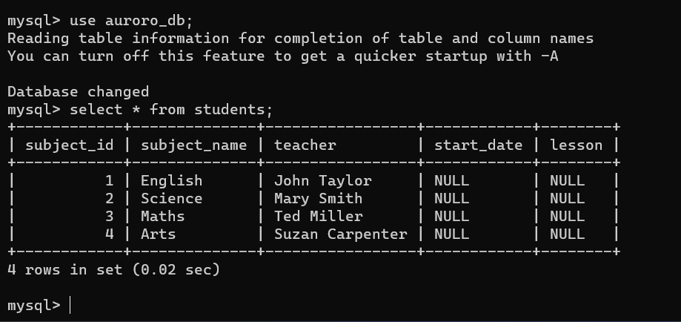

Do you Know?
With Multi-AZ deployment, your database's transaction logs are synchronously replicated to the standby instance. This ensures that your data is durable and protected against potential data loss in the event of a primary instance failure.

